**DAILY ONLINE ACTIVITIES SUMMARY**

|  |  |  |  |  |  |  |  |  |
| --- | --- | --- | --- | --- | --- | --- | --- | --- |
| **Date:** | **18-05-2020** | | | | | **Name:** | **JAIDITHYA** | |
| **Sem & Sec** | **6th B section** | | | | | **USN:** | **4AL17CS118** | |
| **Online Test Summary** | | | | | | | | |
| **Subject** | | **CNSC** | | | | | | |
| **Max. Marks** | | **60** | | **Score** | | | **37** | |
| **Certification Course Summary** | | | | | | | | |
| **Course** | **ML with python** | | | | | | | |
| **Certificate Provider** | | | **cognitive class.ai** | | **Duration** | | | **3hrs** |
| **Coding Challenges** | | | | | | | | |
| **Problem Statement:** Program 1- Using methods charAt() & length() of String class,  Program-2 write a program to print the frequency of each character in a string.  Program 2- Write down a java program to print even and odd numbers series respectively from two threads: t1 and t2 synchronizing on a shared object | | | | | | | | |
| **Status: solved** | | | | | | | | |
| **Uploaded the report in Github** | | | | | **Yes** | | | |
| **If yes Repository name** | | | | | **Daily status-18th** | | | |
| **Uploaded the report in slack** | | | | | **yes** | | | |

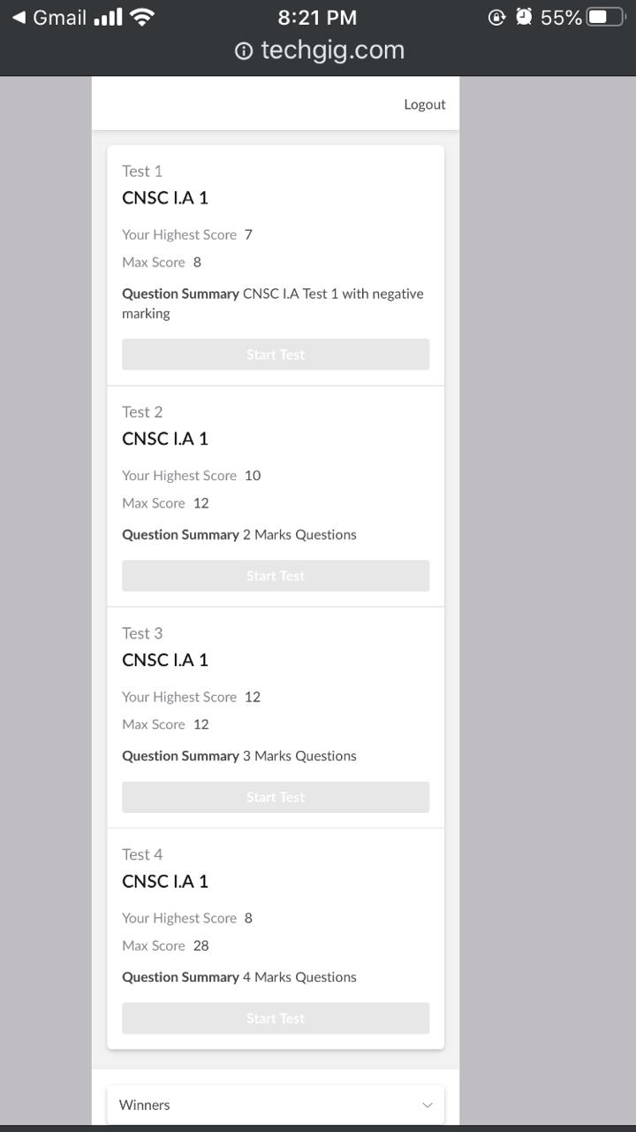

Online test report assessment screenshot

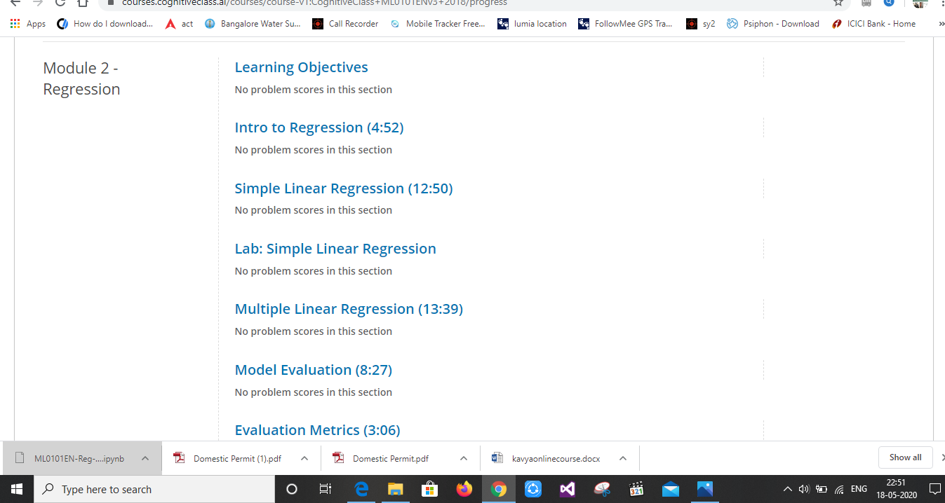Certification course details-Machine learning with python 2 modules completed

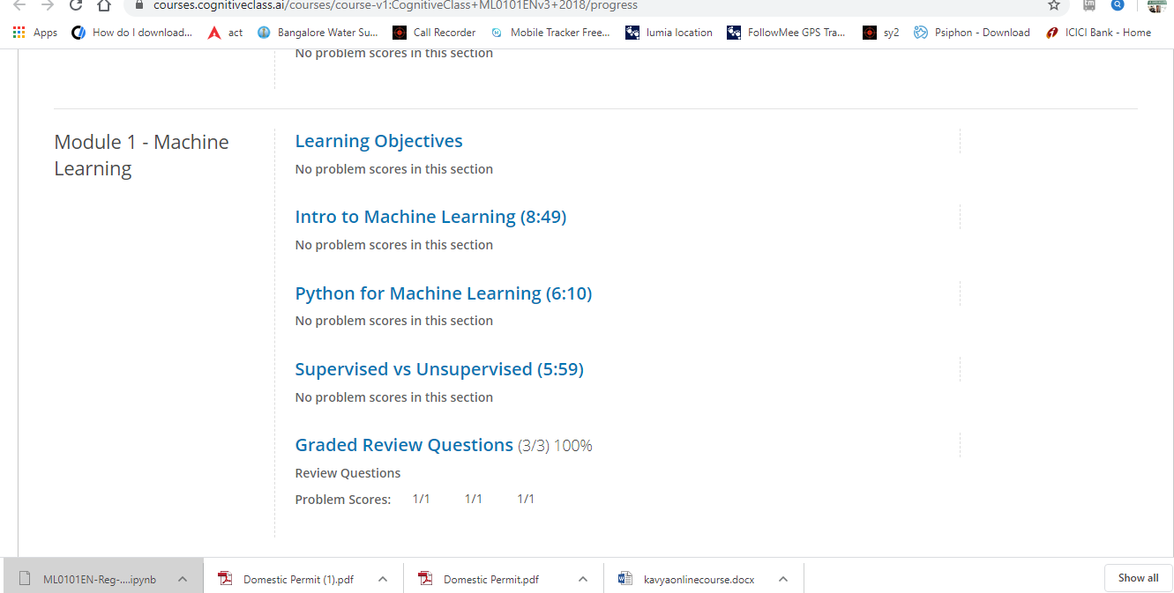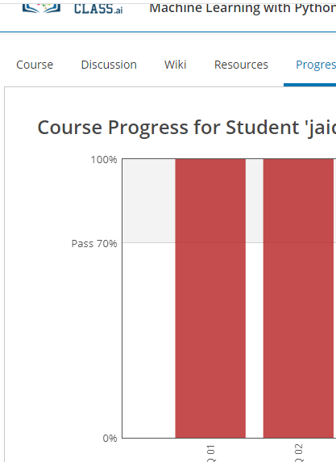

Coding Challenges Details

Program 1- Using methods charAt() & length() of String class, write a program to print the frequency of each character in a string.

Program 2- Write down a java program to print even and odd numbers series respectively from two threads: t1 and t2 synchronizing on a shared object

